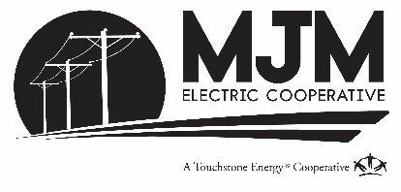

AFFIDAVIT FOR MJM CAPITAL CREDITS

I, _______________________________________ , on oath state:
That my address is_______________________________________________;
The decedent’s name is ____________________________________________;

- The date of the decedent’s death was ____________________________;

- The decedent’s place of residence immediately before death was
____________________________________________________________;

- The decedent’s capital credits from MJM should be paid as follows:
(Below, please write the information of the person or persons to whom we should reissue the capital credits.)
Name | Address | Relationship  to the decedent | Dollar amount or percentage (%) of capital credits to be distributed
(May be completed on the back page, if more room is required.)
Example:
Jane Doe 123 Main St., Anytown, IL 65432 daughter 50%
John Doe 123 Example St., Smalltown, IL 67890 son 50%

By signing, I also state on oath that:
- All of the decedent’s funeral expenses have been paid.
- There are no taxes owed by the decedent, including income, Federal or State estate taxes.
- There is no unpaid claimant or contested claim against the decedent.
- I am unaware of any dispute or potential conflict as to the heirship or will of the decedent.

I, the undersigned, hereby state and affirm that the information contained in this Estate Affidavit is true and correct including that the distribution outlined in paragraph 5 above is the person or entity which is entitled to receive this capital credit distribution. Further, I hereby agree to indemnify and hold M.J.M. Electric Cooperative, Inc. harmless from any and all liability that they might incur as a result of payment of this capital credit based upon this affidavit.

Dated this _______ day of __________, 202___.

________________________________________
(Sign here) Affiant

Please return this form to: MJM Electric Cooperative, Inc.
ATTN: Membership Dept PO Box 80
Carlinville, IL 62626

